**Visvesvaraya Technological University**

**Belagavi-590 018, Karnataka**



A Mini Project Report on

**“CROP MANAGEMENT SYSTEM”**

Mini Project Report submitted in partial fulfillment of the requirement for the

DBMS Laboratory with mini project [18CSL58 ]

Bachelor of Engineering in

ARTIFICIAL INTELLIGENCE AND MACHINE LEARNING

Submitted by

**SHRISHA UDUPA RANGASWAMY .D**

**[1JT20AI041] [1JT20AI033]**

**Under the guidance of:**

**Dr.Madhu B R** **Mrs. Soumya K N**

Professor & HOD Assistant Professor

Department of AIML Department of AIML

JIT,Bengaluru JIT,Bengaluru



**Department of Artificial Intelligence and Machine Learning**

**Jyothy Institute of Technology Tataguni, Bengaluru-560082**

**Jyothy Institute of Technology**

**Tataguni, Bengaluru-560082**

**Department of Artificial Intelligence and Machine Learning**

**CERTIFICATE**

Certified that the mini project work entitled “**Crop Management System**” carried out by **Shrisha Udupa [1JT20AI041] and Rangaswamy D [1JT20AI033]** bona-fide students of Jyothy Institute of Technology, in partial fulfilment for the award of **Bachelor of Engineering Artificial Intelligence and Machine Learning** in department of the **Visvesvaraya Technological University, Belagavi** during the year **2022-2023**. It is certified that all corrections/suggestions indicated for Internal Assessment have been incorporated in the Report deposited in the departmental library. The project report has been approved as it satisfies the academic requirements in respect of Project work prescribed for the said Degree.

**Dr.Madhu B R**  **Mrs.Soumya K N**

Professor & HOD Assistant Professor

Department of AIML Department of AIML

JIT,BengaluruJIT,Bengaluru

Name of the External Examinar Signature of Examiner

1.

2.

**ACKNOWLEDGEMENT**

Firstly, we are very grateful to this esteemed institution **“Jyothy Institute of Technology** ”for providing us an opportunity to complete our project.

We express our sincere thanks to our **Principal Dr . Gopalakrishna K** for providing us with adequate facilities to undertake this project.

We would like to thank **Dr . Madhu B R, Professor and Head of AIML** and Engineering Department for providing his valuable support.

We would like to thank our guides **Mrs. Soumya K N, Assistant Professor Department of AIML** for their keen interest and guidance in preparing this work.

Finally, we would thank all our friends who have helped us directly or indirectly in this project.

**Shrisha Udupa [1JT20AI041]**

**Rangaswamy D [1JT20AI033]**

**ABSTRACT**

For this application, we used the back end as XAMP to store the data which is used in the application, and for the user interface we have used HTML, CSS and the language used is Python

We have designed a database system named, ‘Crop Management System’ database system to make it easy for Users to manage crop transactions

The first activity while using the database is to add the User details to the system along with their personal details.

Later the user can store the crop required using crop id. Users can purchase any crop as well

The Crop can be edited deleted and put for sale

The main aim of developing “Crop Management System Project” application is to help farmers by providing all kinds of agriculture related information in the site. “Crop Management System Project” is web application which helps Users to share Crop data.

It helps farmers to improve their productivity and profitability. It enables farmers to sell their products online and farmers can purchase seeds and crops directly from seller. Farmers can view their profile and they can register, edit and delete data.

The farmers can sell their productions online and the buyer can purchase various agricultural products online. Buyer can send purchase request to check the quality of the product through mails

**TABLE OF CONTENTS**

**1. INTRODUCTION……………………………………………………………………… 6-8**

1.1. INTRODUCTION TO DBMS……………………………………..7

1.2. INTRODUCTION TO SQL………………………………………..7

1.3. INTRODUCTION TO CROP MANAGEMENT SYSTEM……….8

1.4. SCOPE AND IMPORTANCE OF WORK………………………...9

**2. DESIGN……………………………………………….…………10-12**

2.1. THEORY OF ER DIAGRAM……………………..………………11

2.2. ENTITIES……………………………………….............................11

2.3. RELATIONSHIPS………………………………............................12

2.4. ATTRIBUTES……………………………………...........................13

2.5. ER DIAGRAM……………………………………….…………….15

2.6. SCHEMA DIAGRAM……………………………...……………...16

2.7. LIST OF TABLES…………………………………..…..................16

**3. IMPLEMENTATION………………………………..................17-33**

3.1. TABLE CREATION………………………………..……………...18

3.2. TABLE INSERTON……………………………………………….22

3.3. TABLE DESCRIPTION……………………………..……………..24 **4. RESULTS AND SNAPSHOTS…………………….……………27-32**

**5. CONCLUSION…………………………………………………...31-33**

5.1. FEATURES …………………………………..……………………34

5.2. REFERENCES ………………………………...………………….34

5.3 SOFTWARES USED ……………………………………. …………..35

5.4 HARWARE USED ………………………………………………...35

5.5 FUTURE ENCHANCEMENTS……………………………………..36

**CHAPTER 1:**

**INTRODUCTION**

**1.INTRODUCTION**

**1.1 INTRODUCTION TO DBMS:**

A database management system refers to technology for creating and managing databases. DBMS is a software tool to organize (create, retrieve, update and manage) data in a database. The main aim of DBMS is to supply a way to store up and retrieve database

information that is both convenient and efficient.

Advantages of databases:

• To develop software applications in less time.

  Data independence and efficient use of data.

For uniform data administration.

For data integrity and security.

To use user-friendly declarative query language.

Components of DBMS

* Users: Users may be of any kind such as DB administrator, System developer, or database users.
* Database application: Database application may be Departmental, Personal, organization's and / or Internal.
* DBMS: Software that allows users to create and manipulate database access,
* Database: Collection of logical data as a single unit.

**1.2 INTRODUCTION TO SQL:**

SQL is an abbreviation of structured query language, is a language to request data from a database, to add, update, remove data within a database, or to manipulate the metadata of the database.

SQL is a declarative language in which the expected result or operation is given without the specific details about how to accomplish the task. The steps required to execute SQL statement are handled transparently by the SQL database. Sometimes SQL is characterised as non-procedural because procedural language generally require the details of the operations to be specified, such as opening and closing tables, loading and searching indexes, or flushing buffers and writing data to file system. Therefore, SQL is considered to be designed at a higher conceptual level of operation than procedural languages because the lower level logical and physical operation aren't specified and are determined b the SQL engine or server process that executes it.

SQL is used for database architecture and management. Thus, it is a vital tool used by any individual who seeks to pursue a career as a database administrator. For those unfamiliar with programming languages and website architecture, the work of SQL will often go unnoticed. Still, those who have seen behind the curtain will know it as one of the fundamental building blocks of modern database architecture

**1.3 INTRODUCTION TO CROP MANAGEMENT SYSTEM:**

The main objective of crop management system project is to create an application for the user either farmer or customer to modernize the transaction process. And to have the information to be stored digitally. So that the operator can see the details of his crop and also purchase from others . this enhances the transaction capacities and are farmer friendly in nature

Since it is very easy to use anyone can use it with or without the knowledge of the modern computers

Crop management system can be used to store the crops that the farmer currently has which causes a systematic organization of the current crops

If a farmer tend to sell the crop he can give his name , description , price, and Email Id to order directly from the database

**1.4 SCOPE AND IMPORTANCE OF WORK:**

The scope of the project is clear to give a simple and attractive application to simplify the work as well as to reduce the efforts while doing it offline or we can say by doing with old methods.

In this project we are able to store the information of the crops, the user. and crops he has purchased and the payment details. This will mainly help the user to easily view the details of the crops. The main role is played by the farmer who can decide to sell or just store the crop . This application is surely be very useful and comfortable for the farmers and also to the customers.

**CHAPTER 2:**

**DESIGN**

**2.1 -THEORY OF ER DIAGRAM**

An entity relationship diagram shows the relationships of entity sets stored in a database. It mainly describes the structure of a database with the help of a diagram, which is so called the entity relationship diagram. An ER model is the design r blueprint of the database that can later be implemented as a database. The main components of ER model are as said above entity set and relationship set.

ER diagrams are related to data structure diagrams (DSDs), which focus on the relationships of elements within entities instead of relationships between entities themselves. ER diagrams also are often used in conjunction with data flow diagrams (DFDs), which map out the flow of information for processes or systems

**2.2 ENTITIES:**

An entity is an object that exists. It doesn't have to do anything, it just has to exit. In database administration, an entity can be a single thing, person, place, or an object. Data can be stored about such entities. A design tool that allows database administration to view the relationships between several entities is basically called as an ER diagram.

An entity is referred to as an object or thing that exists in the real world. For example, customer, car, pen, etc.

Entities are stored in the database, and they should be distinguishable, i.e., they should be easily identifiable from the group. For example, a group of pens that are from the same company cannot be identified, so they are only objects, but pens with different colours become unique and will be called an entity like a red pen, green pen, blue pen, black pen, etc

n a group of pens, we can easily identify any pen because of its different colours, so a pen of different colours is an entity.

For extracting data from the database, each data must be unique in its own way so that it becomes easier to differentiate between them. Distinct and unique data is known as an entity.

There are two kinds of entities, which are as follows:

**1. Tangible Entity:**

It is an entity in DBMS, which is a physical object that we can touch or see. In simple words, an entity that has a physical existence in the real world is called a tangible entity.

For example, in a database, a table represents a tangible entity because it contains a physical object that we can see and touch in the real world. It includes colleges, bank lockers, mobiles, cars, watches, pens, paintings, etc.

**2. Intangible Entity:**

It is an entity in DBMS, which is a non-physical object that we cannot see or touch. In simple words, an entity that does not have any physical existence in the real world is known as an intangible entity.

For example, a bank account logically exists, but we cannot see or touch it

**2.3 RELATIONSHIPS:**

A relational database collects different types of data sets that use tables, records, and columns. It is used to create a well defined relationship between database tables so that relational database can be easily stored. For example say we need to have a connection between the two entities such as staff and customer we can connect them using the relationship say staff serves customer where serves is the relation that exists between them.

**One to One Relationship (1:1):** It is used to create a relationship between two tables in which a single row of the first table can only be related to one and only one records of a second table. Similarly, the row of a second table can also be related to anyone row of the first table.

**One to Many Relationship:** It is used to create a relationship between two tables. Any single rows of the first table can be related to one or more rows of the second tables, but the rows of second tables can only relate to the only row in the first table. It is also known as a **many to one** relationship.

**Many to Many Relationship:** It is **many to many** relationships that create a relationship between two tables. Each record of the first table can relate to any records (or no records) in the second table. Similarly, each record of the second table can also relate to more than one record of the first table. It is also represented an **N:N** relationship.

**2.4 ATTRIBUTES:**

I In general, an attribute is a characteristic. In a database management system, an

attribute refers to a database component, such as a table. It also may refer to a database field. Attributes describe the instances in the column of a database.

**Simple Attributes**

Simple attributes are those that cannot be further divided into sub-attributes.

Composite Attributes

Composite attributes are made up of two or more simple attributes. For example, a person's address may be a composite attribute that is made up of the person's street address, city, state, and zip code. Composite attributes can be used to create more complex data models and can be helpful when trying to represent data in a concise way.

### Single Valued Attributes

Single-valued attributes can only have one value. For example, a person's Social Security Number is a single-valued attribute. Social Security Numbers are used to uniquely identify individuals in the United States and are, therefore, single-valued attributes.

### Multivalued Attributes

Multivalued attributes can have more than one value. For example, a person may have multiple email addresses or phone numbers. Multivalued attributes in DBMS are often used to store information about relationships between entities. For instance, an employee entity might have a multivalued attribute called "dependents" that stores the names of the employee's dependents. Multivalued attributes can also be used to represent hierarchical data.

### Derived Attributes

Derived attributes are based on other attributes and are not stored directly in the database.

For example: Consider a database of employees. Each employee has a date of birth, and we might want to calculate their age. However, age is a derived attribute because it can be determined from the date of birth. As such, it would not make sense to store it directly in the database. Here is an example diagram of a derived attribute in DBMS:

### Complex Attributes

The complex attribute in DBMS involves both multivalued and composite attributes. For example, someone might have more than one house, and each house might have more than one phone. The phone is then considered a complex attribute.

In the example above, the phone number is a composite attribute of the area code, exchange, and line number. Complex attributes are often used in database design to represent relationships between entities. Here is a complex attribute example explained in the form of a diagram.

**CONCEPTUAL DESIGN**

**2.5 - E.R DIAGRAM**

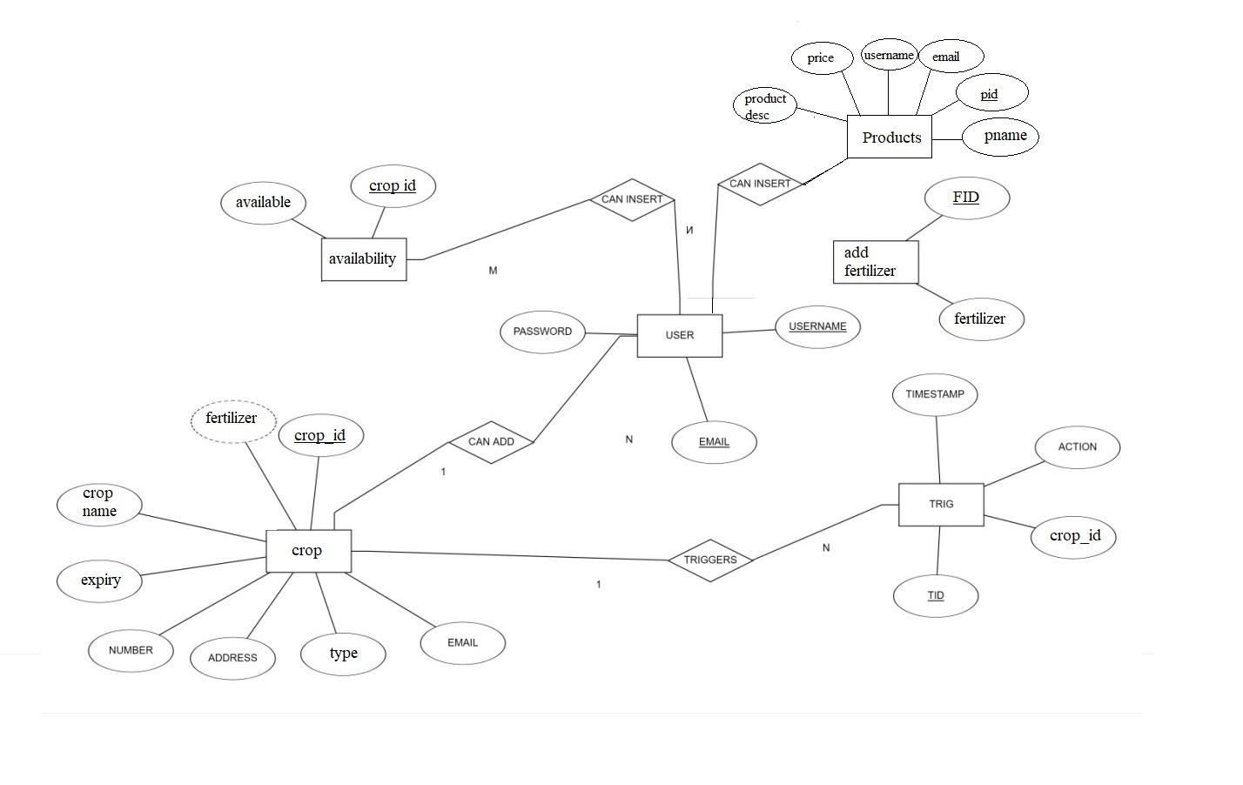

Figure 2.4 : Entity Relationship Diagram of Crop Management System

**2.6 - SCHEMA DIAGRAM**:

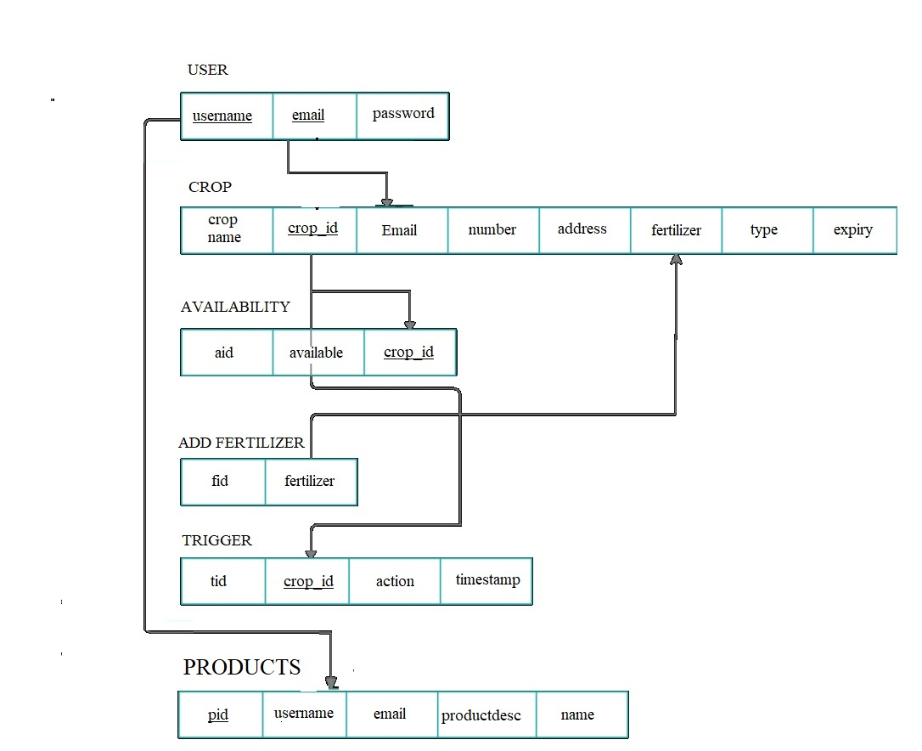

Figure 2.5 : Schema Diagram of Crop Management System

**2.7 LIST OF TABLES**

1.USER

2.CROP

3.AVAILABILITY

4.ADD FERTILIZER

5.TRIGGER

6.PRODUCTS

**CHAPTER 3:**

**IMPLEMENTATON**

**3.1 CREATE TABLE STATEMENTS**

Database: `crops`

-- Table structure for table `Availability`

CREATE TABLE `Availability` (

`aid` int(11) NOT NULL,

`cropid` varchar(20) NOT NULL,

`availability` int(100) NOT NULL

)

-- Table structure for table `department`

CREATE TABLE `fertilizer` (

`fid` int(11) NOT NULL,

`fertilizer` varchar(50) NOT NULL

)

-- Table structure for table `crop`

CREATE TABLE `crop` (

`cropid` varchar(20) NOT NULL,

`cropname` varchar(50) NOT NULL,

`availability` int(20) NOT NULL,

`type` varchar(50) NOT NULL,

`fertilizer` varchar(50) NOT NULL,

`email` varchar(50) NOT NULL,

`number` varchar(12) NOT NULL,

`address` text NOT NULL)

-- Table structure for table `test`

CREATE TABLE `test` (

`id` int(11) NOT NULL,

`name` varchar(52) NOT NULL,

`email` varchar(50) NOT NULL

)

-- Dumping data for table `test`

INSERT INTO `test` (`id`, `name`, `email`) VALUES

CREATE TABLE `trig` (

`tid` int(11) NOT NULL,

`cropid` varchar(50) NOT NULL,

`action` varchar(50) NOT NULL,

`timestamp` datetime NOT NULL

)

CREATE TABLE `user` (

`id` int(11) NOT NULL,

`username` varchar(50) NOT NULL,

`email` varchar(50) NOT NULL,

`password` varchar(500) NOT NULL

)

ALTER TABLE `Availability`

ADD PRIMARY KEY (`aid`);

ALTER TABLE `Fertilizer`

ADD PRIMARY KEY (`fid`);

ALTER TABLE `crop`

ADD PRIMARY KEY (`cropid`);

ALTER TABLE `test`

ADD PRIMARY KEY (`id`);

ALTER TABLE `trig`

ADD PRIMARY KEY (`tid`);

ALTER TABLE `user`

ADD PRIMARY KEY (`id`);

ALTER TABLE `Availability`

MODIFY `aid` int(11) NOT NULL AUTO_INCREMENT, AUTO_INCREMENT=7;

ALTER TABLE `fertilizer`

MODIFY `fid` int(11) NOT NULL AUTO_INCREMENT, AUTO_INCREMENT=9;

ALTER TABLE `crop`

MODIFY `cropid` int(11) NOT NULL AUTO_INCREMENT, AUTO_INCREMENT=7;

ALTER TABLE `test`

MODIFY `id` int(11) NOT NULL AUTO_INCREMENT, AUTO_INCREMENT=2;

ALTER TABLE `trig`

MODIFY `tid` int(11) NOT NULL AUTO_INCREMENT, AUTO_INCREMENT=10;

ALTER TABLE `user`

MODIFY `id` int(11) NOT NULL AUTO_INCREMENT, AUTO_INCREMENT=5;

**3.2 INSERT INTO VALUES**

**INSERT INTO AVAILABILITY**

INSERT INTO `Availability` (`aid`, `cropid`, `availability`) VALUES(6, '18pot11', 12);

**INSERT INTO FERTILIZER**

INSERT INTO `fertilizer` (`fid`, `fertilizer`) VALUES

(2, 'Ammoniacal Fertilizer'),

(3, 'Sodium Nitrate'),

(4, 'Calcium Ammonium Nitrate'),

(5, 'Urea '),

(7, 'Cyanamide'),

(8, 'Citrate');

**TRIGGERS:**

Triggers `crop`

--

DELIMITER $$

CREATE TRIGGER `DELETE` BEFORE DELETE ON `crop` FOR EACH ROW INSERT INTO trig VALUES(null,OLD.rollno,'CROP DELETED',NOW())

$crop

DELIMITER ;

DELIMITER $$

CREATE TRIGGER `Insert` AFTER INSERT ON `crop` FOR EACH ROW INSERT INTO trig VALUES(null,NEW.rollno,'CROP INSERTED',NOW())

$$

DELIMITER ;

DELIMITER $$

CREATE TRIGGER `UPDATE` AFTER UPDATE ON `crop` FOR EACH ROW INSERT INTO trig VALUES(null,NEW.rollno,'CROP UPDATED',NOW())

$$ DELIMITER

**INSERT INTO TEST**

INSERT INTO `test` (`id`, `name`, `email`) VALUES

(1, 'aaa', 'aaa@gmail.com');

**INSERT INTO TRIGGER**

INSERT INTO `trig` (`tid`, `cropid`, `action`, `timestamp`) VALUES

(7, '18pot11', 'CROP INSERTED', '2021-01-10 19:19:56'),

(8, '18pot12', 'CROP UPDATED', '2021-01-10 19:20:31'),

(9, '18pot13', 'CROP DELETED', '2021-01-10 19:21:23');

**INSERT INTO USER**

INSERT INTO `user` (`id`, `username`, `email`, `password`) VALUES

(4, 'anees', 'anees@gmail.com', ‘123456');

**3.3 TABLE DESCRIPTIONS**

**SELECT* FROM TABLES**

**USER**

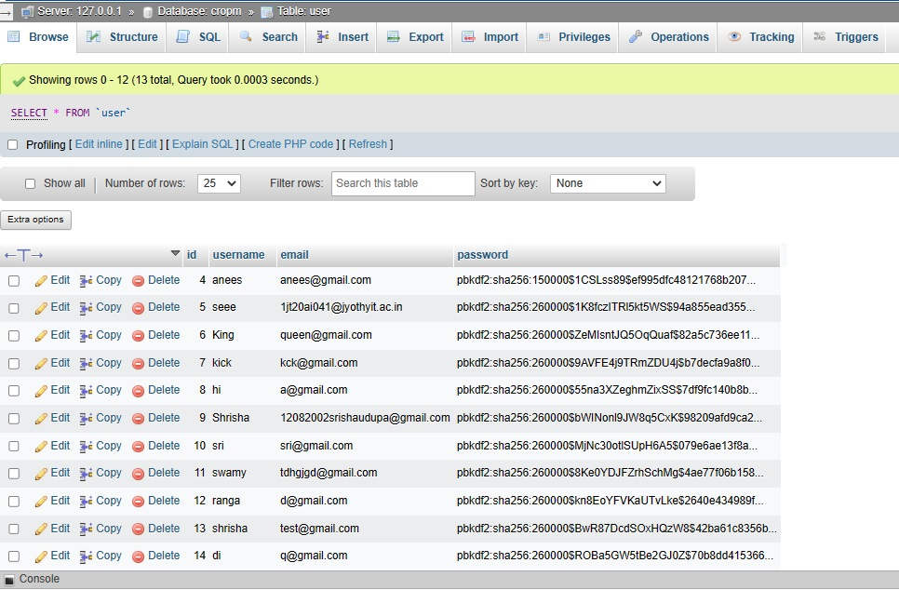

Figure 3.3.1: User Table

**CROP**

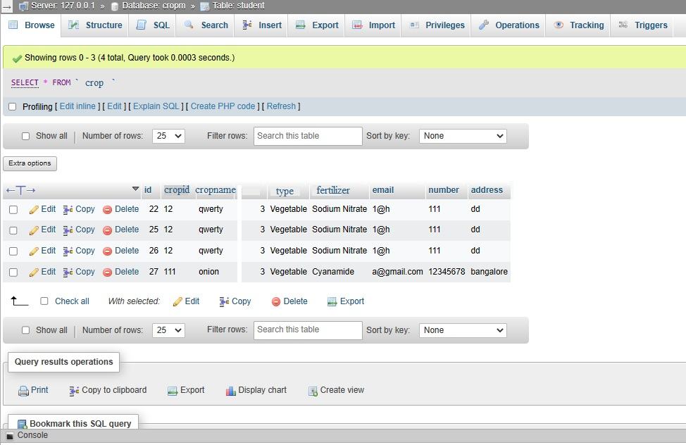

Figure 3.3.2 : Crop Table

**AVAILABILITY**

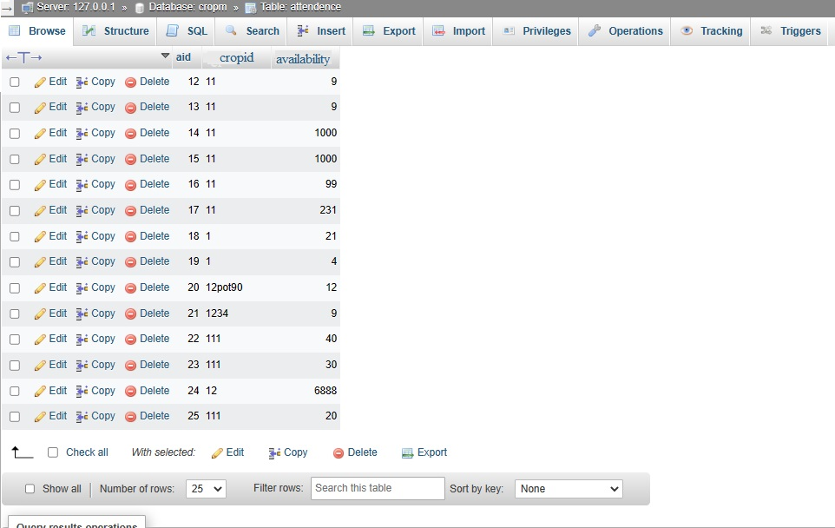

Figure 3.3.3 : Availability Table

**FERTILIZER**

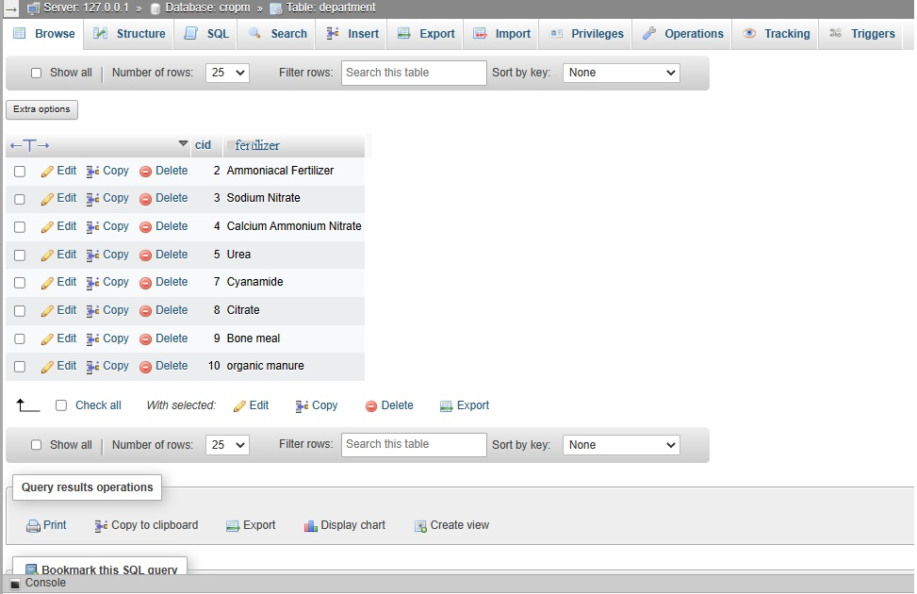Figure 3.3.4: Fertilizer Table

**PRODUCT**

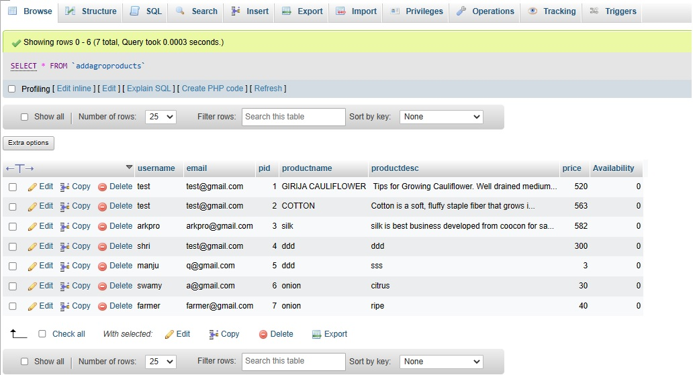

Figure 3.3.5: Product Table

**TRIGGER**

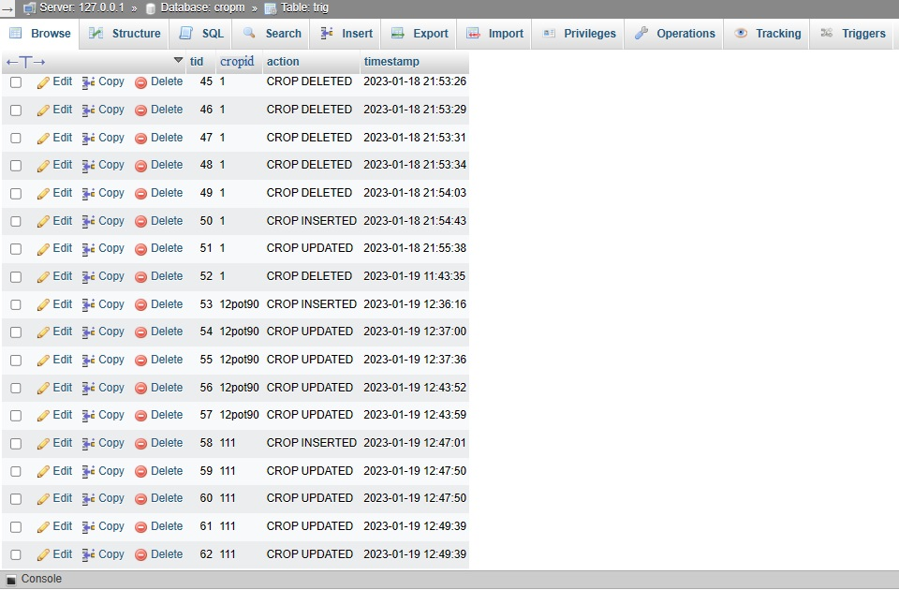Figure 3.3.6 : Trigger Table

**CHAPTER 4:**

**RESULT AND SNAPSHOT**

**HOME PAGE**

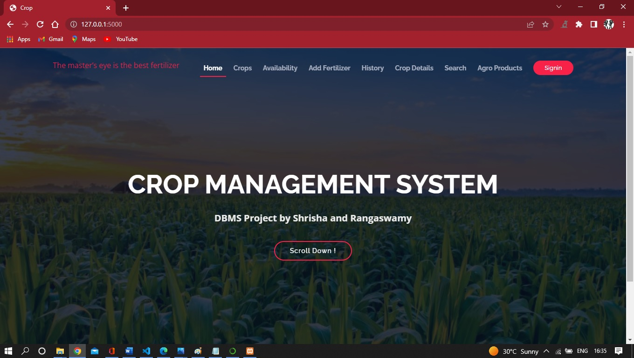

Figure 4.1: Home Page

**SIGNUP PAGE**

Z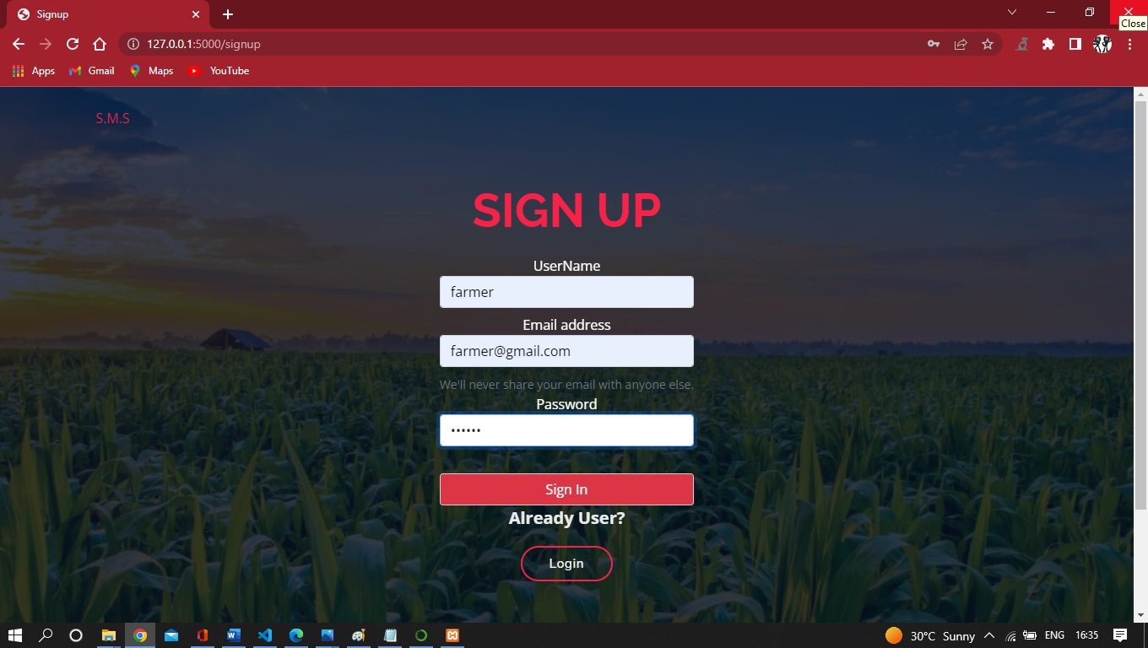

Figure 4.2 : Signup Page

**LOGIN PAGE**

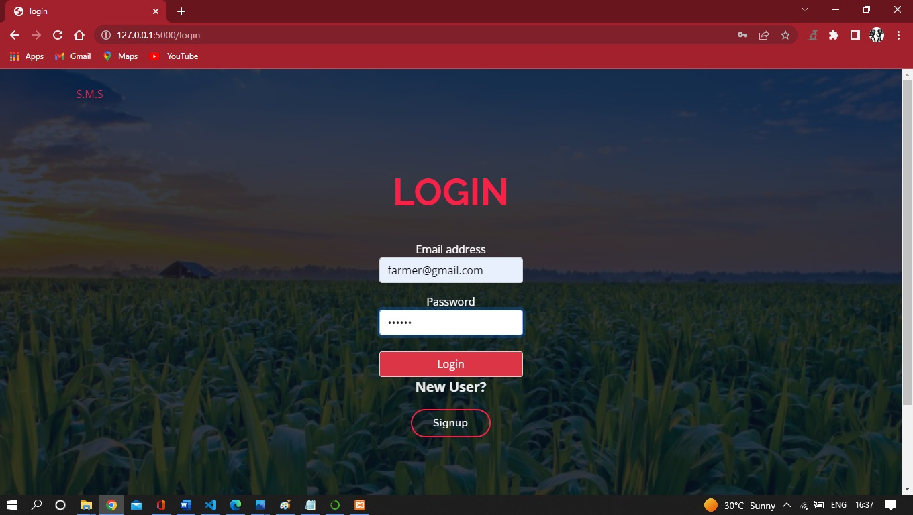

Figure 4.3: Login Page

**CROP TABLE**

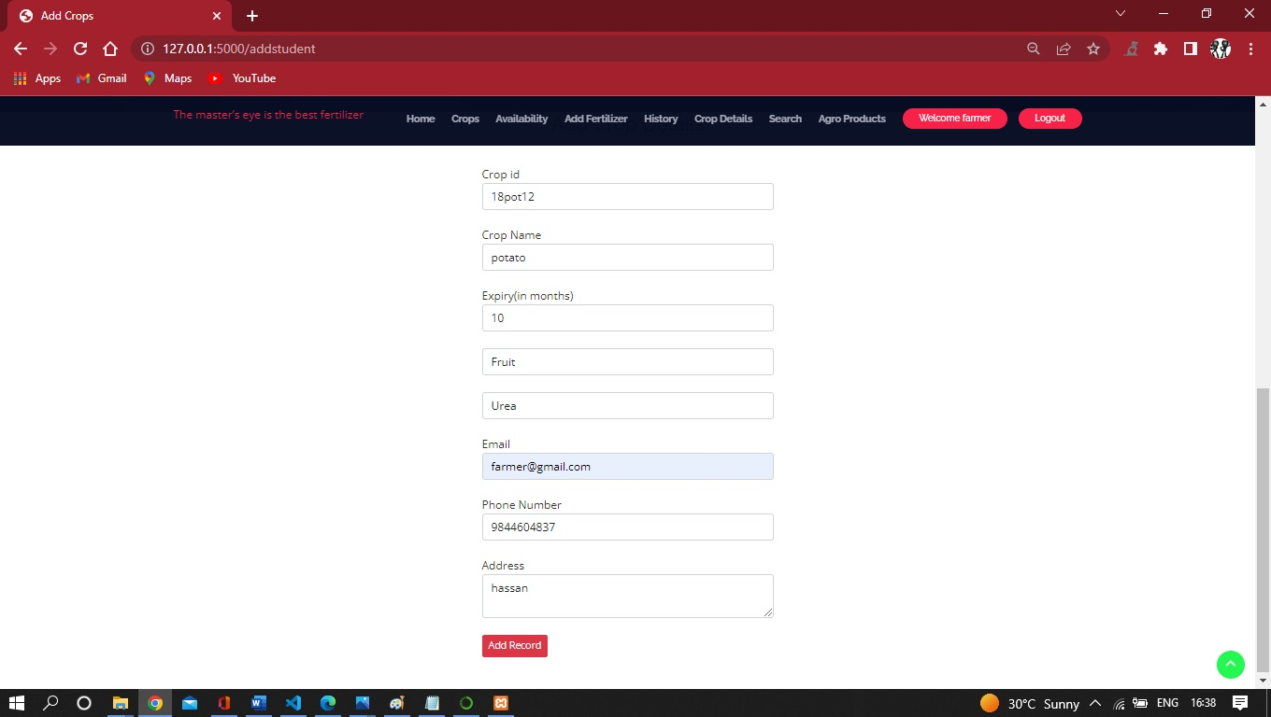

Figure 4.4: Crop Table

**ADD AVAILABILITY TABLE**

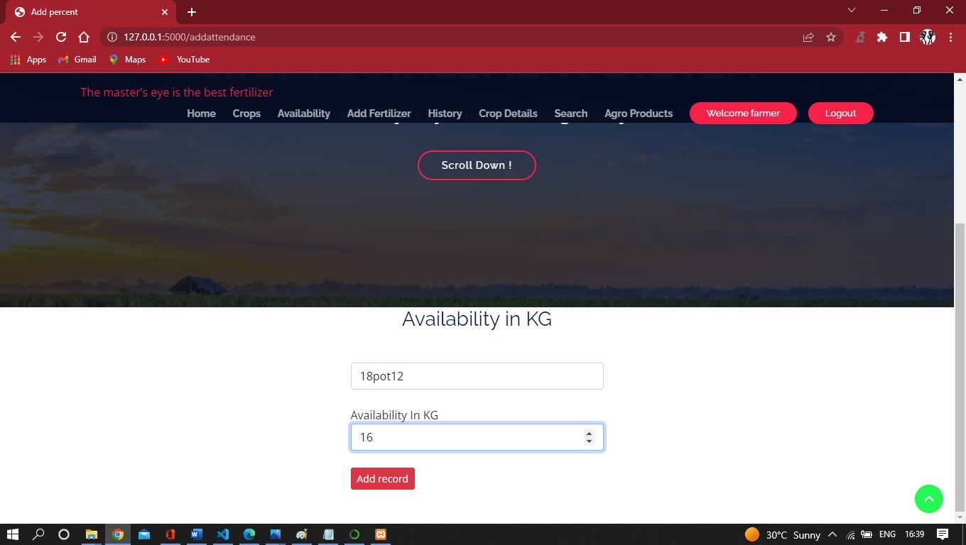

Figure 4.5: Availability

**FERTILIZER**

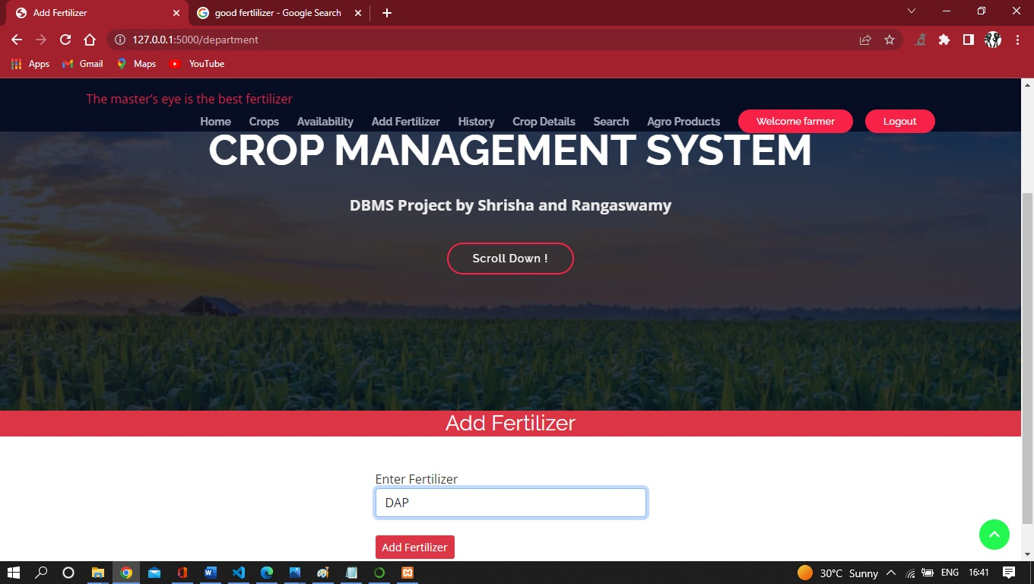

Figure 4.6: Fertilizer

**CROP DETAILS**

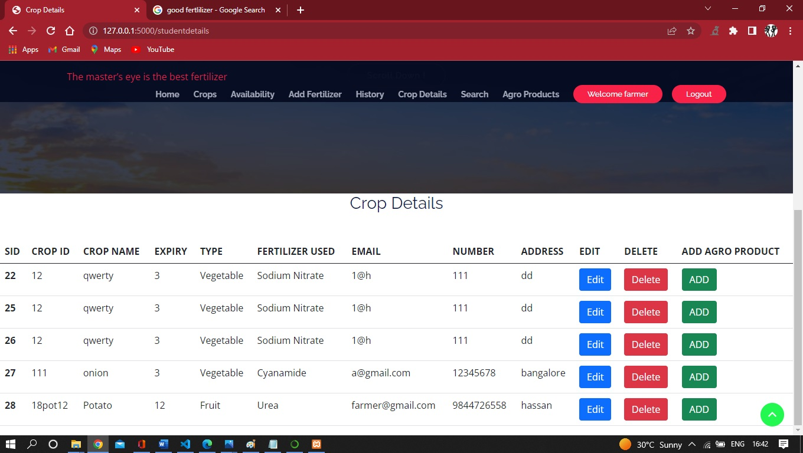

Figure 4.7:Crop Details

**HISTORY**

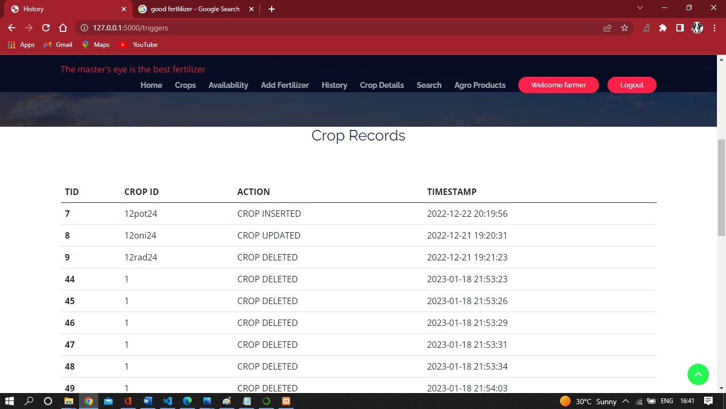

Figure 4.8: History

**PRODUCTS**

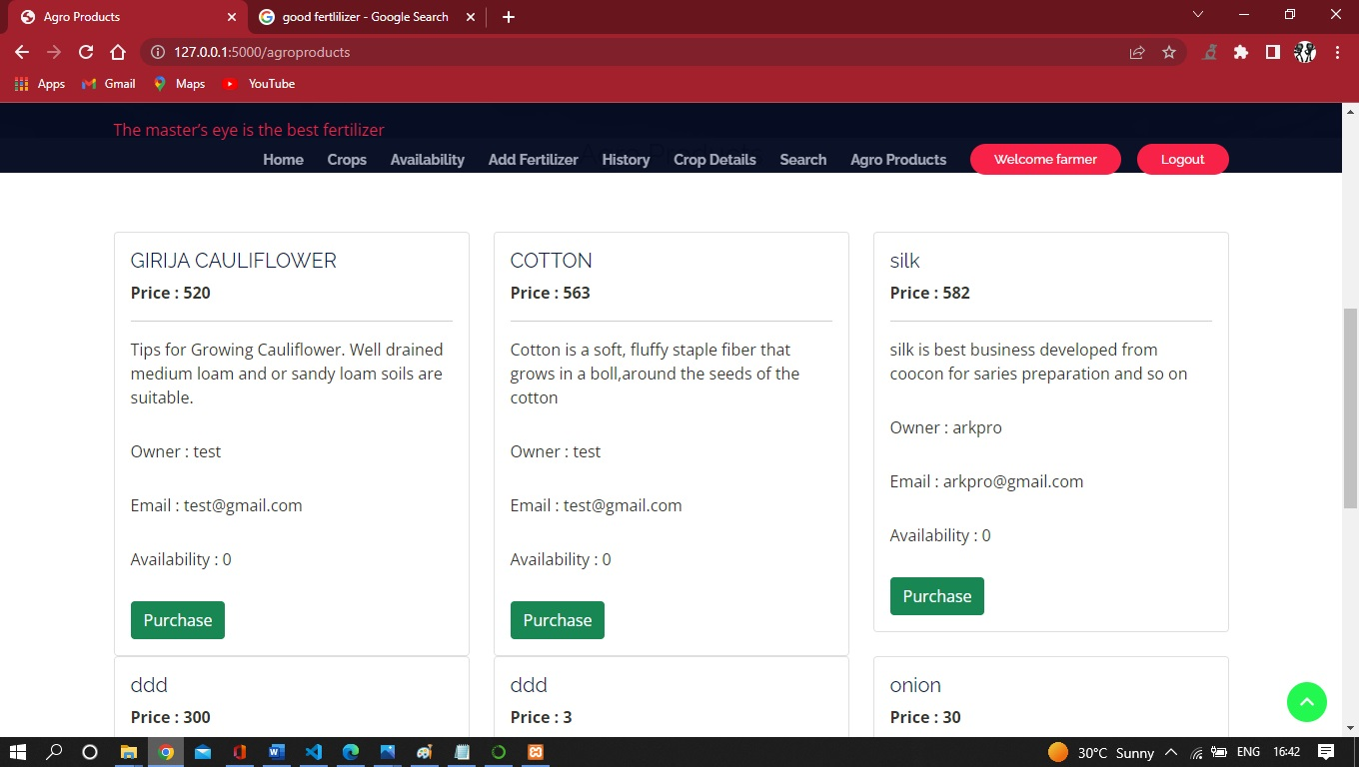

Figure 4.9: Products

**CHAPTER 5:**

**CONCLUSION**

We have successfully implemented the CROP MANAGEMENT SYSTEM DATABASE which makes easier for user to manage crop management for the farmers

View tables are used to display all the components of different entities user needs. One can just select the buttons and modify the data as per requirements

We have successfully used various functionalities of HTML,CSS and PYTHON and created the fully functional database system

Crop management system can be used to manage the Crop handling and facilitate a simple transaction in the end helping farmers to sell to customer who orders through Email

In this project many farmer can add the crop into the database easily and sell any crop he needs

**5.1 FEATURES**

User can update the crop inside the database and also update the availability of the crop

If a Fertilizer used is not already present user can add the fertilizer used

User can edit the crop if the information updated is wrong or needs any changing

User can delete the crop whenever required

A customer can purchase the crop directly by sending the Email to the farmer giving the address

**5.2 REFERENCES**

**1.-** Fundamentals of Database Systems, RamezElmasri and Shamkant B. Navathe, 7th Edition, 2017, Pearson

**2**- Database management systems, Ramakrishnan, and Gehrke, 3rd Edition, 2014, McGraw Hill

3-SilberschatzKorth and Sudharshan, Database System Concepts, 6th Edition, Mc-GrawHill, 2013.

**4-** Coronel, Morris, and Rob, Database Principles Fundamentals of Design, Implementation and Management, Cengage Learning 2012

5- www.youtube.com

6- [www.github.com](http://www.github.com)

7- [www.w3schools.com](http://www.w3schools.com)

8- Python IDLE:

<https://www.python.org/downloads/>

9- [www.javatpoint.com/xampp](http://www.javatpoint.com/xampp)

10- <https://www.g2.com/categories/crop-management>

11- www.getbootstrap.com

**5.3 SOFTWARE USED**

Frontend- HTML, CSS, Java Script, Bootstrap

Backend-Python flask (Python 3.7) , SQLAlchemy,

Operating System: Windows 10

Google Chrome/Internet Explorer

XAMPP (Version-3.7)

Python main editor (user interface): PyCharm Community

workspace editor: Sublime text 3

**5.4 HARDWARE USED**

Computer with a 1.1 GHz or faster processor

Minimum 2GB of RAM or more

2.5 GB of available hard-disk space

5400 RPM hard drive

1366 × 768 or higher-resolution display

DVD-ROM drive

**5.5 FUTURE ENHANCEMENTS**

Enhanced database storage facility

Enhanced user friendly GUI

more advanced results systems

online payments